PROMOTIONAL TOOLKIT
NCDPI and NCDHHS 877-877 Meal Locator Texting Resource for Parents
April 13, 2020

OVERVIEW
To help increase awareness of local meal distribution sites serving children across North Carolina, we invite you to please help promote the “text FOODNC to 877-877" texting service in both English and Spanish. For the Spanish-language version users text COMIDA to 877-877.

ASK
We are asking community stakeholders to help spread the word about this resource for families, especially those families who may be struggling to feed their children in these unprecedented times. We’ve included sample social media posts below to help you broadly promote the 877-877 texting tool within your networks. This information can also be shared via newsletters or any other communication channels you use to reach your networks.

SAMPLE WEB/E-NEWSLETTER COPY (ENGLISH)

Families who need help finding meals for their children ages 18 and younger can text FOODNC to 877-877 to locate nearby free meal sites. The texting service is also available in Spanish by texting COMIDA to 877-877.

After entering their address, families will receive a text with the location and serving times for nearby pick-up and drive-thru meal sites while schools are closed. Sites have been set up across the state with school and community partners.

SAMPLE WEB/E-NEWSLETTER COPY (SPANISH)
Las familias que necesitan ayuda para encontrar comidas para sus hijos hasta los 18 años pueden enviar un mensaje de texto a COMIDA al 877-877 para ubicar los sitios de comida gratis cercanos a usted. Después de ingresar su dirección, las familias recibirán un mensaje de texto con la ubicación y las horas de servicio para los lugares de comida cercanos para recoger la comida desde su auto, mientras las escuelas están cerradas. Se han establecido sitios de comida en todo el estado en escuelas y organizaciones de la comunidad.

SOCIAL MEDIA PROMOTION (ENGLISH & SPANISH)
Suggested Hashtags:
Feel free to use your own organizational or local hashtags, or add one of these to your posts:
- #COVID19NC  - #OurNCSchoolHeroes  - #nced | - #PTchat  - #resourcesforparents

Sample Twitter Post (ENGLISH):

Do you need help finding meals for your child? Text FOODNC to 877-877. Enter your address and you will get a text back with the location and serving times of nearby sites offering free meals for children ages 18 and younger. Sites are set up across NC. #COVID19NC #nced

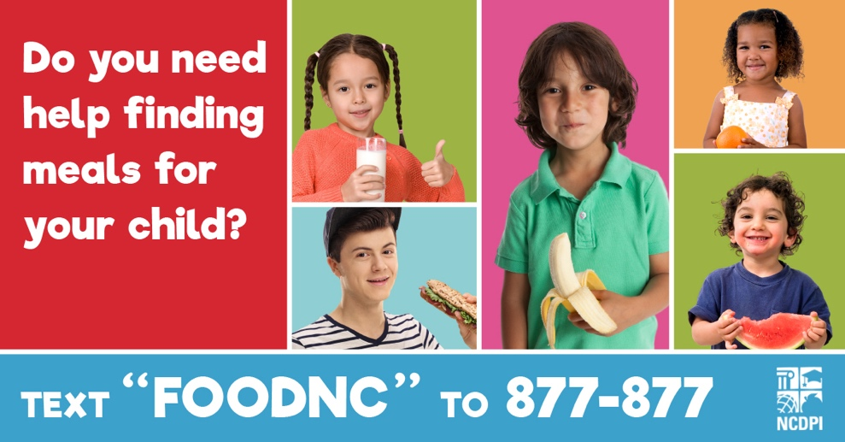

Sample Twitter Post (SPANISH):

¿Necesita ayuda para encontrar comidas para su hijo? Envía texto a COMIDA al 877-877. Ingrese su dirección y recibirá un mensaje de texto con la ubicación y los horarios de los sitios cercanos que ofrecen comidas gratis para niños hasta los 18 años. #COVID19NC #nced

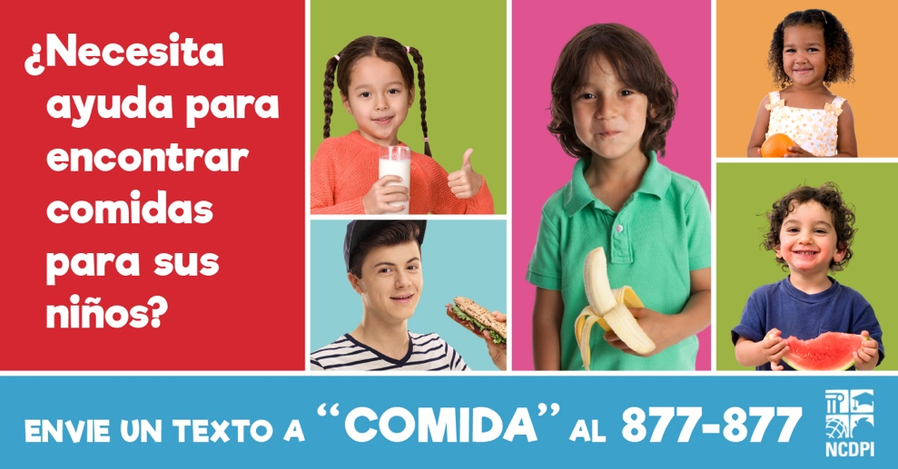

Sample Facebook Post (ENGLISH):

Do you need help finding meals for your child? Text FOODNC to 877-877. After you enter your address, you will get a text back with the location and serving times of nearby sites offering free meals for children ages 18 and younger. Sites are set up across NC. #COVID19NC

Sample Facebook Post (SPANISH):

¿Necesita ayuda para encontrar comidas para su hijo? Envíe texto a COMIDA al 877-877. Después de ingresar su dirección, recibirá un mensaje de texto con el lugar y los horarios de sitios cercanos a usted que ofrecen comidas gratis para niños hasta los 18 años. Hay sitios de comida en todo Carolina del Norte.

Sample Instagram Post (ENGLISH):

Do you need help finding meals for your child? Text FOODNC to 877-877. After you enter your address, you will get a text back with the location and serving times of nearby sites offering free meals for children ages 18 and younger. Sites are set up across NC. #COVID19NC

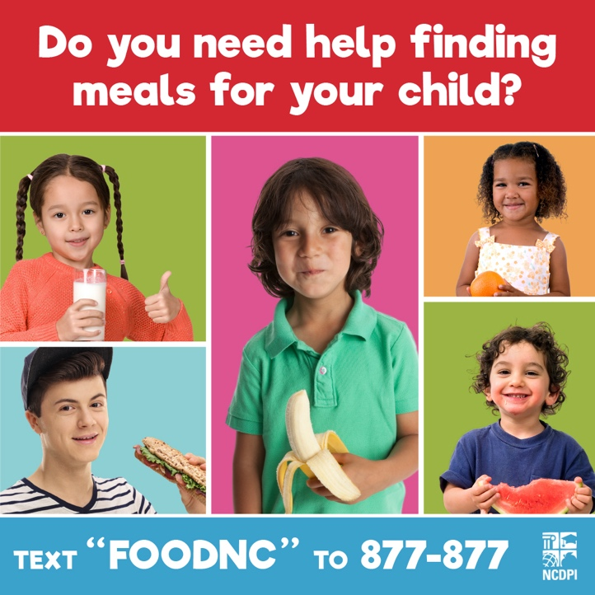

Sample Instagram Post (SPANISH):

¿Necesita ayuda para encontrar comidas para su hijo? Envíe texto a COMIDA al 877-877. Después de ingresar su dirección, recibirá un mensaje de texto con el lugar y los horarios de sitios cercanos a usted que ofrecen comidas gratis para niños hasta los 18 años. Hay sitios de comida en todo Carolina del Norte. #COVID19NC
ADDITIONAL IMAGES PROVIDED:

Twitter and Facebook Images (ENGLISH):
Below are images that have been designed with image ratios to work best with Facebook and Twitter.

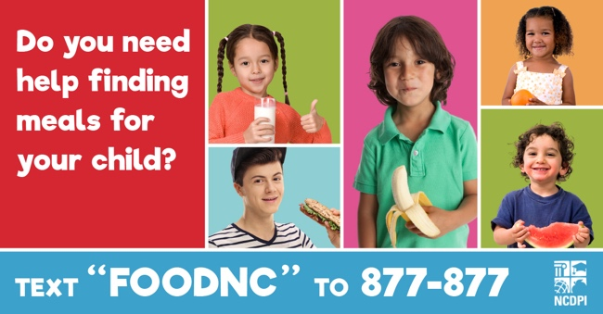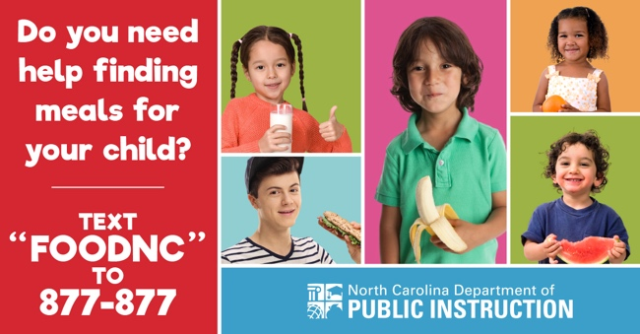
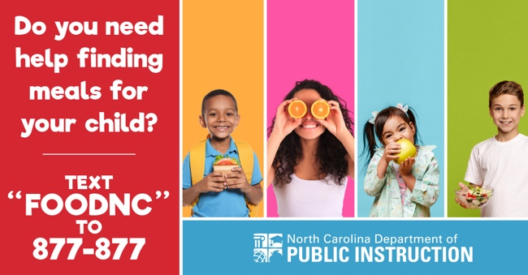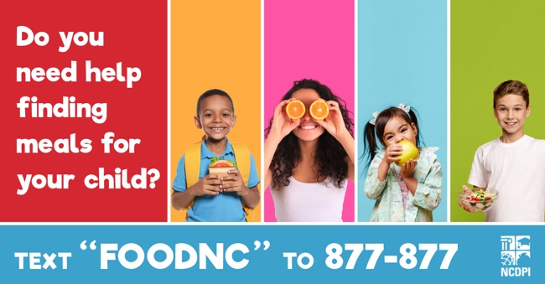
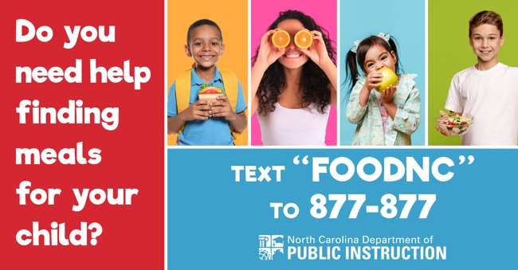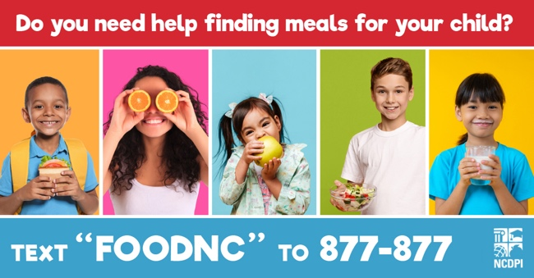

Twitter and Facebook Images (SPANISH):
Below are images that have been designed with image ratios to work best with Facebook and Twitter.

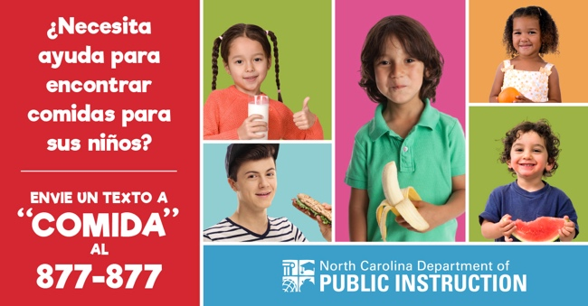
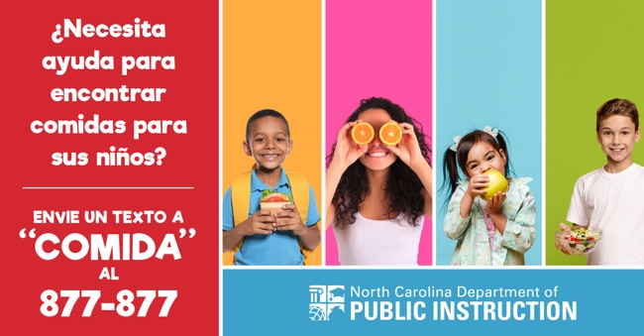
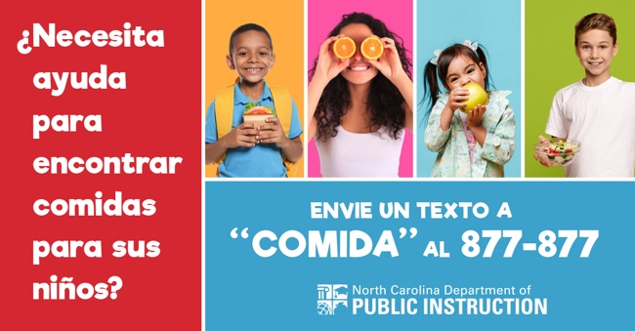

Instagram Images (ENGLISH):

Below are four images that have been designed with image ratios that work best with Instagram.

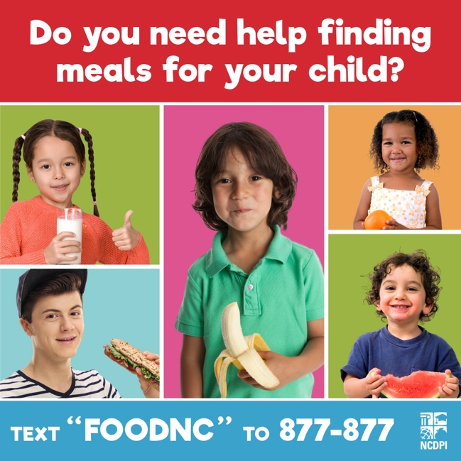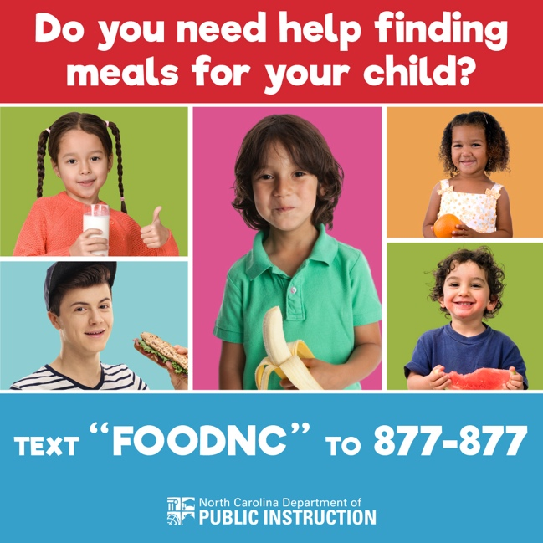

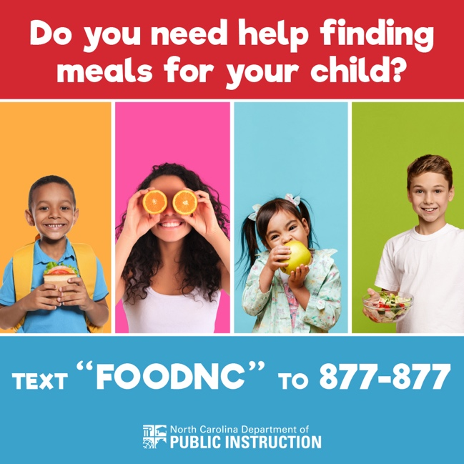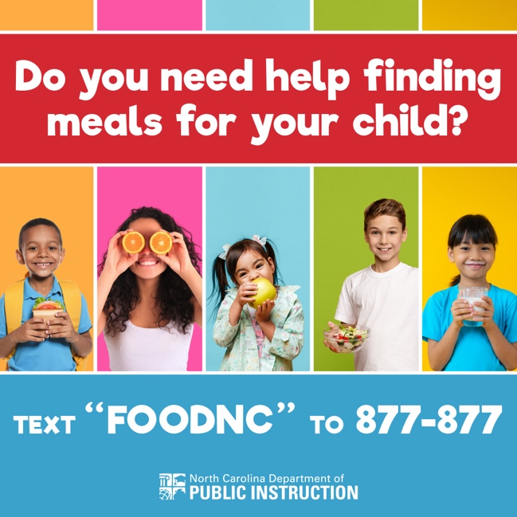

Instagram Images (SPANISH):

Below are four images that have been designed with image ratios that work best with Instagram.

